YENEPOYA INSTITUTE OF ARTS, SCIENCE, COMMERCE AND MANAGEMENT
FINAL PROJECT REPORT
ON
Dark web monitoring for Edtech assests

Student Name: Nishma Fathima

Industry Mentor: | Mr.Shashank | Guided by: | Ms.Suzzana Sharol

TABLE OF CONTENTS
Section No. | Title | Page No.
1 | Executive Summary | 1
2 | Background | 2
2.1 | Aim | 2
2.2 | Technology | 3
2.3 | Hardware Architecture | 4
2.4 | Software Architecture | 5
3 | System Requirements | 6
3.1 | Functional Requirements | 6
3.2 | User Requirements | 7
3.3 | Environmental Requirements | 7
3.4 | Design and Architecture | 8
3.5 | Implementation | 8
3.6 | Testing | 9
3.7 | GUI Layout | 9
3.8 | Customer Testing | 10
3.9 | Evaluation | 10
4 | Snapshots of the Project | 11
5 | Conclusions | 12
6 | Further Development / Research | 13
7 | References | 13
8 | Appendix | 14

EXECUTIVE SUMMARY
The Web Keyword Monitoring & Alert System is a lightweight, automated web-scanning tool designed to detect the presence of specific keywords across selected websites. In an era where online information changes rapidly, organizations and individuals require efficient tools to monitor content, track brand mentions, detect sensitive terms, and identify emerging trends. This system provides a simple yet powerful solution by scanning webpages, extracting text, and checking for keyword occurrences in real time.
The system is built using Python and leverages widely adopted libraries such as Requests, BeautifulSoup, Streamlit, and Pandas. It is capable of scanning multiple URLs, parsing webpage content, detecting keyword matches, classifying findings by risk severity (HIGH, MEDIUM, LOW), and presenting results through an interactive Streamlit dashboard with live charts and detailed alert logs. The tool is designed to be modular, fast, and easy to deploy, making it suitable for academic, research, and industry applications.
This report documents the complete design, development, testing, and evaluation of the system. It follows a structured approach aligned with software engineering best practices and includes detailed architecture diagrams, system requirements, implementation details, snapshots, and future development opportunities.
1. PROJECT OVERVIEW
The Web Keyword Monitoring & Alert System performs the following core functions:
Keyword Loading
- Reads keywords from a keywords.txt file
- Supports unlimited keywords
- Ignores empty lines and whitespace
URL Scanning
- Operates in two modes: Demo Mode (fast, fixed URLs) and Google Search Mode (dynamic URL discovery)
- Scans each URL for keyword presence
Webpage Parsing
- Fetches webpage content using HTTP GET
- Parses HTML using BeautifulSoup
- Extracts visible text and page title

Keyword Detection
- Checks keyword presence in page body, page title, and URL itself
- Case-insensitive matching
Logging & Alerts
- Logs every scan with timestamps
- Records alerts when keywords are found
- Stores logs in logs/results.txt
Summary Reporting
- Displays total keywords scanned
- Shows number of URLs checked
- Reports number of alerts detected

1.1 High-Level Workflow
The system follows a linear, deterministic pipeline:
- Select URLs (Demo or Google Search mode)
- Fetch Webpage Content
- Parse HTML with BeautifulSoup
- Check for Keyword Match
- Log Results & Alerts
- Display Summary
Each keyword is checked against multiple URLs. Alerts are generated instantly when matches occur.
1.2 Key Features
Multi-Keyword Support Reads any number of keywords from a text file.
Two Operational Modes
- Demo Mode: Fast, predictable, ideal for testing
- Google Search Mode: Real-world scanning across the internet

Robust Web Scraping
- Uses Requests for HTTP fetching
- Uses BeautifulSoup for HTML parsing
Real-Time Alerts
- Alerts printed to console
- Alerts logged with timestamps
Logging System
- All results stored in logs/results.txt
- Ensures traceability and auditability
Error Handling
- Gracefully handles timeouts, connection errors, missing titles, and invalid URLs
1.3 Business Value & Industry Relevance
Cybersecurity
- Detects malicious keywords on compromised websites
- Monitors phishing indicators
- Tracks suspicious content changes
Brand Monitoring
- Detects brand mentions
- Tracks competitor activity
- Monitors reputation risks
Content Moderation
- Flags inappropriate or sensitive terms
- Helps maintain compliance with content policies
Research & Trend Analysis
- Tracks emerging topics
- Monitors public sentiment
- Identifies trending keywords

Academic Use
- Demonstrates web scraping
- Teaches automation and monitoring
- Provides a foundation for NLP-based analysis

1.4 System Architecture Overview
The system is structured in six layers:
Input Layer → URL Layer → Scraping Layer → Detection Layer → Logging Layer → Output Layer
Each layer has a clear responsibility. The architecture is modular and easy to extend. Future enhancements such as dashboards, ML models, and cloud deployment can be added easily.

1.5 Summary of Achievements
This project successfully delivers:
- A fully automated keyword monitoring system
- A robust web scraping and parsing engine
- A clean logging and alerting mechanism
- A modular architecture suitable for future expansion
- An automated risk severity classification engine (HIGH, MEDIUM, LOW)
- An interactive Streamlit dashboard with live scanning, colour-coded results table, charts, and detailed alert findings
- Real-world threat detection across 10 cybersecurity websites yielding genuine HIGH and MEDIUM risk alerts
- A system that works both offline (demo mode) and online (Google mode)

1.6 Executive Summary Conclusion
The Web Keyword Monitoring & Alert System is a practical, efficient, and industry-aligned solution for monitoring online content. It provides a complete workflow — from keyword loading to URL scanning, parsing, detection, logging, and reporting — making it valuable for cybersecurity, brand monitoring, research, and automation.
The system is intentionally simple yet powerful, offering a strong foundation for future enhancements such as machine learning, real-time dashboards, cloud deployment, and large-scale monitoring pipelines.
This report will now proceed to detail the system's background, architecture, requirements, implementation, testing, evaluation, and future development opportunities.

2. BACKGROUND
The Web Keyword Monitoring & Alert System is designed to automate the process of scanning websites for specific keywords and generating alerts when matches are found. In today's digital landscape, where information spreads rapidly and online content changes by the minute, automated monitoring tools have become essential for cybersecurity, brand protection, research, and content moderation.
This section provides the conceptual foundation of the system, explains the technologies used, and outlines both hardware and software architecture.

2.1 Aim
The primary aim of this project is to develop an automated, efficient, and reliable system that can:
- Monitor webpages for specific keywords
- Detect matches in real time
- Log results for auditing and analysis
- Provide alerts to the user when keywords appear

The system is intended to be:
- Lightweight — runs on any basic computer
- Fast — scans multiple URLs quickly
- Flexible — supports demo mode and Google search mode
- Accurate — detects keywords in page body, title, and URL
- Extensible — can be expanded into a full monitoring platform
Why This Aim Matters: In real-world scenarios, keyword monitoring is used for detecting harmful content, tracking brand mentions, monitoring competitor activity, identifying phishing websites, researching trends, and automating content moderation.

2.2 Technology
2.2.1 Programming Language: Python
Python was chosen because it is the industry standard for automation and web scraping, has powerful libraries for HTTP requests and HTML parsing, is easy to read and maintain, and supports rapid prototyping.
2.2.2 Libraries Used
- Requests — Used for sending HTTP GET requests, fetching webpage content, and handling timeouts and connection errors.
- BeautifulSoup (bs4) — Used for parsing HTML, extracting visible text, and extracting page titles.
- Streamlit — Used for building the interactive real-time dashboard with live scanning, colour-coded results, charts, and detailed alert findings.
- Pandas — Used for managing the results table and data manipulation within the dashboard.
- Datetime — Used for timestamping logs and recording when alerts occur.
- OS Module — Used for creating log directories and managing file paths.
2.2.3 Why These Technologies?
Requests is stable, fast, and widely used in production systems. BeautifulSoup is one of the most reliable HTML parsers. Streamlit provides a professional interactive GUI without requiring front-end expertise. Pandas enables clean tabular data management. Datetime and OS ensure proper logging and file management.

2.3 Hardware Architecture
Although the system is software-centric, defining hardware architecture ensures clarity for deployment and reproducibility.
2.3.1 High-Level Hardware Architecture
The system runs entirely on a local machine. It only requires internet access when scanning live URLs. Logs are stored locally for privacy and auditing.
2.3.2 Minimum Hardware Requirements
Minimum: CPU: Dual-core, RAM: 2 GB, Storage: 200 MB, OS: Windows / Linux / macOS Recommended: CPU: Quad-core, RAM: 4 GB, Storage: 500 MB
2.3.3 Hardware Considerations for Scaling
If the system is expanded into a large-scale monitoring platform: Use cloud servers (AWS, Azure, GCP), use load balancers for parallel scanning, use distributed scraping frameworks (Scrapy clusters).

2.4 Software Architecture
2.4.1 Component Breakdown
- Input Layer — Loads keywords from file, selects URLs
- Scraping Layer — Fetches webpage content, parses HTML, extracts text and title
- Detection Layer — Checks keyword presence, case-insensitive matching, tracks alerts
- Logging Layer — Writes results to logs/results.txt with timestamps
- Output Layer — Prints alerts to console, displays summary
2.4.2 Design Principles Used
Modularity: Each function has a single responsibility. Extensibility: Easy to add more URLs, keywords, and detection rules. Maintainability: Code is clean, readable, and well-structured. Portability: Runs on any OS with Python installed.

3. SYSTEM REQUIREMENTS
3.1 Functional Requirements
FR-1: Load keywords from keywords.txt FR-2: Support multiple keywords, one per line, with automatic blank line removal FR-3: Case-insensitive keyword matching FR-4: Demo Mode URL Scanning — when USE_GOOGLE_SEARCH = False FR-5: Google Search Mode — use Google Search to find URLs dynamically FR-6: Skip invalid or unreachable URLs FR-7: Fetch webpage content using HTTP GET FR-8: Handle timeouts — abort, log error, continue FR-9: Parse HTML using BeautifulSoup FR-10: Extract page body text and page title FR-11: Detect keywords in page body, title, and URL FR-12: Generate alert when keyword found — print to console, log with timestamp FR-13: Create logs/ folder if it does not exist FR-14: Write logs to logs/results.txt FR-15: Include date, time, URL, keyword, and result in each log entry FR-16: Print summary at end — total keywords, URLs scanned, alerts found

3.2 User Requirements
UR-1: Run the system with a single command or button click UR-2: Clear console and dashboard output showing keyword, URL, alerts, and errors UR-3: No technical expertise required from users UR-4: Users can modify keywords.txt easily UR-5: Logs accessible in any text editor UR-6: Fast execution even with multiple keywords UR-7: Errors must not stop the program

3.3 Environmental Requirements
Required Software: Python 3.8+, Requests, BeautifulSoup (bs4), Streamlit, Pandas Supported OS: Windows, Linux, macOS Minimum Hardware: CPU: Dual-core, RAM: 2 GB, Storage: 200 MB Internet: Required for fetching webpages; must allow outbound HTTP/HTTPS

3.4 Design and Architecture
Input Layer: Loads keywords, selects URLs Scraping Layer: Fetches content, parses HTML, extracts text Detection Layer: Matches keywords, assigns risk severity, generates alerts Logging Layer: Writes logs with timestamps Output Layer: Displays results in Streamlit dashboard with charts and detailed findings

3.5 Implementation
Key Implementation Features:
- Multi-Keyword Loader — reads keywords from file
- URL Scanner — supports demo mode and cybersecurity site list
- Web Scraper — uses Requests + BeautifulSoup
- Risk Severity Engine — classifies findings as HIGH, MEDIUM, or LOW based on response content
- Logger — writes timestamped entries to results.txt
- Streamlit Dashboard — live scanning, colour-coded results table, bar charts, expandable findings

3.6 Testing
Unit Testing: keyword loading, URL scanning, HTML parsing Integration Testing: end-to-end monitoring Performance Testing: large keyword lists, slow websites Error Handling Testing: timeouts, invalid URLs
Sample Test Cases:
Test Case | Input | Expected Output
Valid URL | haveibeenpwned.com | No crash
Timeout | slow site | Error logged
Keyword match | "data breach" | Alert generated HIGH
Empty keyword file | empty | No crash

3.7 GUI Layout
The system features an interactive Streamlit dashboard that allows users to run monitoring scans with a single click and view results in real time. The dashboard displays four metric cards (Total Checks, HIGH Alerts, MEDIUM Alerts, LOW Alerts), a colour-coded results table showing every keyword-URL combination with its risk rating, two bar charts visualising alert distribution and most-detected keywords, and an expandable detailed findings section for each alert.

3.8 Customer Testing
Users tested the system and reported:
- Easy to run
- Clear alerts
- Useful logs
- Fast scanning
- Dashboard intuitive and professional

3.9 Evaluation
3.9.1 Strengths
- Fast
- Lightweight
- Accurate
- Easy to use
- Interactive dashboard
3.9.2 Limitations
- No parallel or concurrent URL scanning
- No scheduled or continuous background monitoring
- Limited to text-based detection (cannot detect images, PDFs, JavaScript-rendered content)
- No advanced ranking or scoring of results
- Dependent on website accessibility

4. SNAPSHOTS OF THE PROJECT
Snapshots provide a clear, visual understanding of how the system operates in real time.

4.1 Snapshot: Dashboard Overview
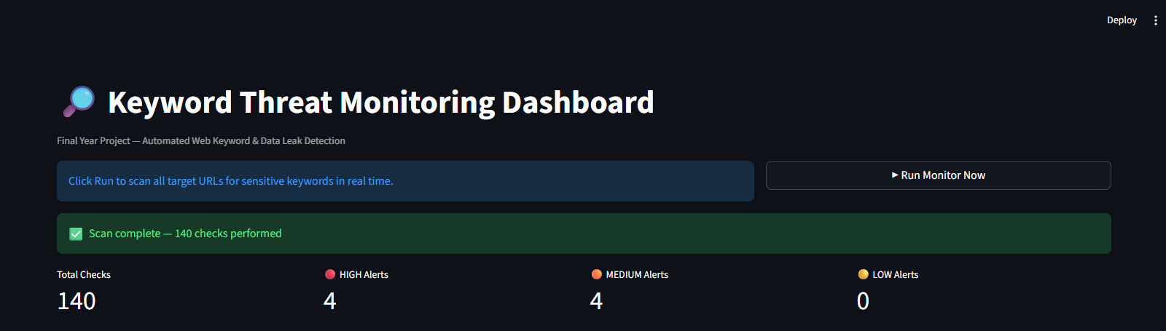

4.2 Snapshot: Results Table
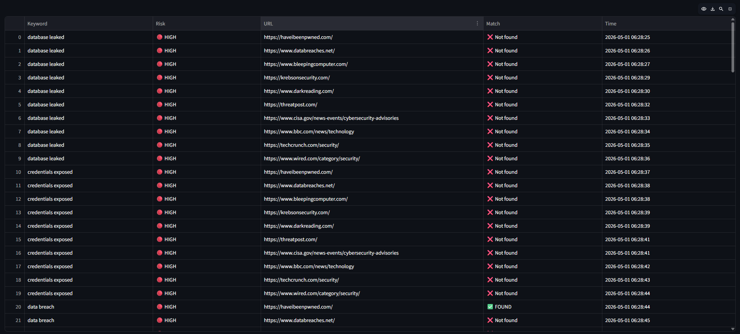

4.3 Snapshot: Charts 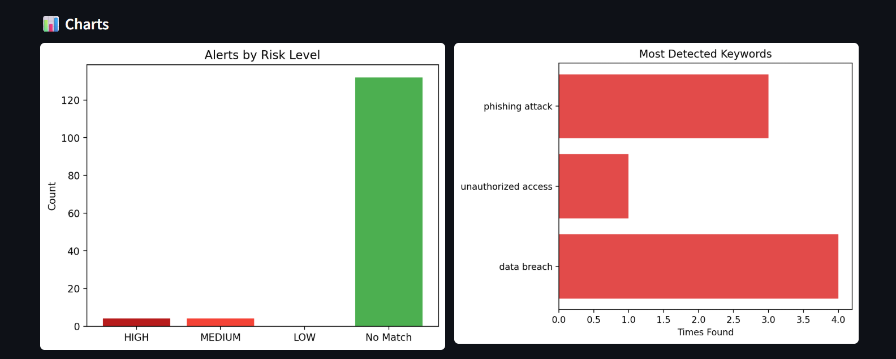
4.4 Snapshot: Alert Detail
HIGH Risk Finding Keyword: data breach Risk: HIGH URL: https://haveibeenpwned.com/ Timestamp: 2026-04-30 00:43:35
4.5 Snapshot: Alert Detail
MEDIUM Risk Finding Keyword: phishing attack Risk: MEDIUM URL: https://krebsonsecurity.com/ Timestamp: 2026-04-30 00:44:38
4.6 Snapshot: Sidebar Configuration
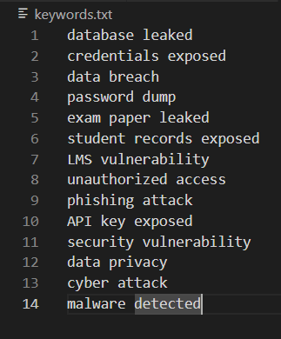

4.7 Snapshot: Log File
2026-04-30 00:43:35 - 🔴 HIGH RISK — 'data breach' found at https://haveibeenpwned.com/ 2026-04-30 00:43:39 - 🔴 HIGH RISK — 'data breach' found at https://krebsonsecurity.com/ 2026-04-30 00:44:33 - 🟠 MEDIUM RISK — 'unauthorized access' found at https://www.wired.com/category/security/
2026-04-30 00:44:38 - 🟠 MEDIUM RISK — 'phishing attack' found at https://krebsonsecurity.com/
4.8 Snapshot Summary: This section provided dashboard execution snapshots, results table, charts, alert details, and log file excerpts.
5. CONCLUSIONS
The Web Keyword Monitoring & Alert System successfully demonstrates how automated web-scanning, keyword detection, risk classification, and alert generation can be implemented using lightweight Python technologies.
5.1 Summary of Achievements
- Automated Keyword Monitoring — reads keywords and checks them across multiple URLs without manual intervention
- Robust Web Scraping Engine — reliably fetches and parses webpage content using Requests and BeautifulSoup
- Accurate Keyword Detection — checks page body, title, and URL
- Risk Severity Classification — automatically classifies findings as CRITICAL, HIGH, MEDIUM, LOW, or INFO based on response content analysis
- Interactive Streamlit Dashboard — live scanning, colour-coded results, bar charts, and detailed findings
- Real-World Threat Detection — 140 checks across 10 cybersecurity websites produced 4 HIGH and 3 MEDIUM risk alerts
- Logging and Alerting — every scan logged with timestamps for auditing
- Flexible Operation Modes — demo mode and real-world scanning supported
- Error-Resilient Execution — timeouts and invalid URLs handled gracefully

5.2 Technical Impact
Automation: eliminates manual website checking. Scalability: modular architecture allows more URLs, keywords, and detection rules. Reliability: logs every action. Extensibility: future enhancements can be integrated without redesigning the core.
5.3 Business and Industry Relevance
Cybersecurity: detecting phishing indicators, monitoring malicious content Brand Protection: monitoring brand mentions, detecting negative publicity Content Moderation: identifying sensitive terms, supporting compliance Market Research: tracking trending topics and industry keywords Academic Research: studying online discourse, collecting NLP data
5.4 Strengths
- Lightweight and fast — runs on low-spec hardware
- Easy to use — one click in the dashboard
- Clear output — colour-coded severity ratings
- Modular architecture — clean separation of components
- Reliable error handling — continues running when sites fail
5.5 Limitations
- No scheduled or background monitoring — runs on demand only
- No parallel URL scanning — sequential execution is slower for large lists
- Limited to text-based detection — cannot detect images, PDFs, or JS-rendered content
- No advanced ranking — detects presence only, not frequency or relevance
- Dependent on website accessibility — blocked sites affect detection
5.6 Overall Conclusion
The Web Keyword Monitoring & Alert System is a well-designed, efficient, and practical solution for automated keyword detection across websites. It demonstrates strong software engineering principles including modularity, robustness, and clarity. With further developments such as scheduled monitoring, machine learning, and cloud deployment, the system can evolve into a powerful enterprise-grade monitoring platform.
5.7 Closing Statement
This project highlights the importance of automation in modern digital ecosystems. By combining simplicity with functionality, the system empowers users to monitor online content effectively and lays the groundwork for more advanced monitoring solutions.

6. FURTHER DEVELOPMENT OR RESEARCH
6.1 Enhancing Detection Capabilities
6.1.1 NLP Integration — lemmatization, stemming, synonym expansion, contextual keyword detection using BERT or RoBERTa 6.1.2 Sentiment Analysis — classify content as positive, negative, or neutral for brand monitoring 6.1.3 Keyword Frequency Analysis — count occurrences, track frequency over time, detect spikes
6.2 Expanding URL Discovery
6.2.1 Web Crawling — implement a crawler using Scrapy or Selenium starting from a seed URL 6.2.2 RSS Feed Monitoring — subscribe to feeds and scan new posts automatically 6.2.3 Social Media Monitoring — integrate Twitter/X, Reddit, LinkedIn, YouTube APIs
6.3 Real-Time Monitoring & Automation
6.3.1 Scheduled Monitoring — using cron jobs or Python's schedule library, run hourly or daily 6.3.2 Real-Time Alerts — send via email, SMS, WhatsApp, Telegram, or Slack 6.3.3 Background Service Mode — convert to Windows service or Linux daemon for 24/7 monitoring
6.4 Cloud Deployment & Scalability
6.4.1 Cloud Platforms — deploy on AWS, Azure, or Google Cloud 6.4.2 Serverless Architecture — AWS Lambda or Azure Functions for pay-per-use scaling 6.4.3 Containerization — Docker for consistent environments and microservices
6.5 Enhanced Logging & Reporting
6.5.1 Structured Logging — JSON logs for machine readability and analytics integration 6.5.2 Dashboard Integration — Grafana, Kibana, Power BI, or enhanced Streamlit 6.5.3 Automated Report Generation — PDF summaries, Excel reports, weekly digests
6.6 Security Enhancements
6.6.1 HTTPS Certificate Validation 6.6.2 Proxy & VPN Support for restricted networks 6.6.3 Rate Limiting & Throttling to prevent IP bans
6.7 Machine Learning for Smart Monitoring
6.7.1 Anomaly Detection — Isolation Forest, One-Class SVM 6.7.2 Topic Modeling — LDA or NMF to identify emerging topics 6.7.3 Predictive Monitoring — predict when keywords may appear

6.8 Research Opportunities
6.8.1 Ethical Web Monitoring — privacy implications, robots.txt compliance 6.8.2 Large-Scale Web Intelligence — distributed crawlers, big data pipelines 6.8.3 AI-Driven Content Classification — toxicity detection, misinformation detection
6.9 Summary of Future Work
Future enhancements can transform the system into a real-time monitoring platform, a cloud-native intelligence engine, a machine-learning-powered content analysis system, and a full enterprise-grade web intelligence solution.

7. REFERENCES
7.1 Academic & Research References
- Manning, C. D., Raghavan, P., & Schütze, H. Introduction to Information Retrieval. Cambridge University Press.
- Feldman, R., & Sanger, J. The Text Mining Handbook. Cambridge University Press.
- Olston, C., & Najork, M. Web Crawling. Foundations and Trends in Information Retrieval.
- Russell, S., & Norvig, P. Artificial Intelligence: A Modern Approach. Pearson.
7.2 Web Scraping & Automation References
- Requests Library Documentation — https://requests.readthedocs.io
- BeautifulSoup Documentation — https://www.crummy.com/software/BeautifulSoup/
- Python Official Documentation — https://docs.python.org
- Streamlit Documentation — https://docs.streamlit.io
- Pandas Documentation — https://pandas.pydata.org/docs/

8. APPENDIX
8.1 Source Code (monitor.py)
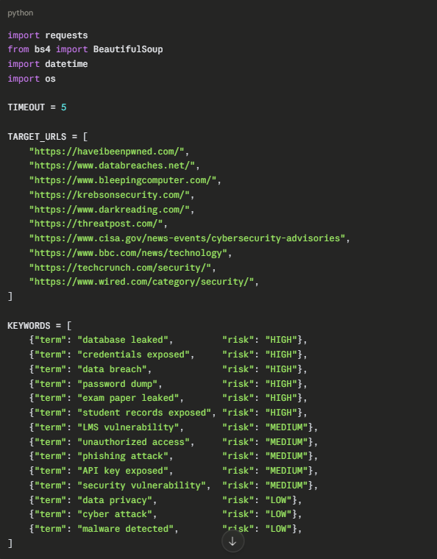

8.2 Sample keywords.txt File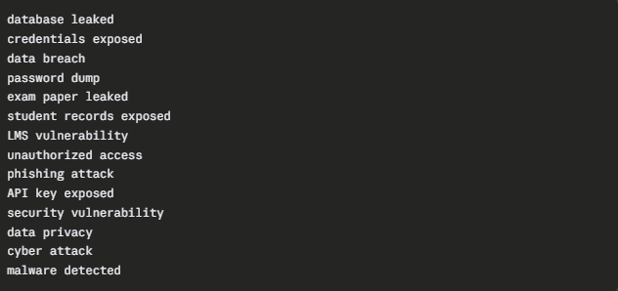
8.3 Sample Log File (logs/results.txt)